**Prediction of blood sugar levels in diabetic patients**

**Overview:**

This project uses a Random Forest Regressor to predict blood sugar levels.

**Specifically, the project uses the following steps to perform blood sugar level prediction:**

1. Data loading and preprocessing: Load the diabetes dataset from scikit-learn and split it into training and test sets.
2. Hyperparameter tuning: Use randomized search cross-validation to find the best hyperparameters for the random forest regressor model.
3. Model training and evaluation: Train the random forest regressor model with the best hyperparameters and evaluate its performance using the training and test sets.
4. Feature importance visualization: Analyze the feature importance of the random forest regressor model to understand which features are most important for blood sugar level prediction.

**The basis for predicting blood sugar levels is:**

* 10 physiological features of the patient, including age, gender, weight, blood pressure, cholesterol level, etc.
* The patient's past blood sugar level measurements.

**The results of this project show that:**

* The random forest regressor model can effectively predict blood sugar levels.
* The patient's age, weight, blood pressure, cholesterol level and other features have an important impact on blood sugar level prediction.

**The potential applications of this project include:**

* Helping diabetic patients better manage their blood sugar levels.
* Developing diabetes treatment devices such as artificial pancreas.

**The limitations of this project include:**

* The dataset used is relatively small.
* The performance of the model may vary due to individual differences between patients.

**Overall, this project provides a useful reference for using machine learning to predict blood sugar levels.**

**1. Theoretical Understanding and Background:**

**Ensemble learning principles**

Ensemble learning is a machine learning method that combines multiple learners to improve overall performance. The basic principle is:

* Train multiple base learners, each of which can be any type of machine learning model.
* Combine the predictions of the base learners to get the final prediction.

**Ensemble learning can effectively improve the performance of the model, mainly for the following reasons:**

* Reduces the risk of overfitting: Each base learner may have an overfitting problem, but ensemble learning can reduce the risk of overfitting by combining the predictions of multiple base learners.
* Improves generalization ability: Ensemble learning can improve the generalization ability of the model by combining the knowledge of multiple base learners.
* Improves robustness: Ensemble learning can improve the robustness of the model by reducing the reliance on a single base learner.

**Random Forest Regressor**

Random Forest Regressor is an ensemble learning algorithm that uses multiple decision trees as base learners. The basic principle is:

* Randomly sample data from the training set and use this data to train multiple decision trees.
* When predicting, average the predictions of multiple decision trees to get the final prediction.

Random Forest Regressor has the following advantages:

* High accuracy: Random Forest Regressor can effectively reduce the risk of overfitting, so it has high accuracy.
* Strong generalization ability: Random Forest Regressor can combine the knowledge of multiple decision trees, so it has strong generalization ability.
* Good robustness: Random Forest Regressor can reduce the reliance on a single decision tree, so it has good robustness.

**The theoretical foundation of Random Forest Regressor mainly includes the following aspects:**

* Decision tree: Decision tree is a commonly used machine learning model, which can classify or regress data through a series of conditional judgments.
* Ensemble learning: Ensemble learning is a machine learning method that combines multiple learners to improve overall performance.
* Randomness: Random Forest Regressor introduces randomness into the training process, which can effectively reduce the risk of overfitting.

**Overfitting problem, generalization ability, robustness**

**The overfitting problem**   
refers to the situation where the model performs well on the training set but does not perform well on unknown data. This is usually because the model has over-learned the noise and features in the training data, which makes it difficult to generalize well to new data.

**Generalization ability**   
refers to the ability of a model to predict unknown data. A model with good generalization ability is able to learn general patterns from the training data and perform well on new data.

**Robustness**   
refers to the sensitivity of a model to data perturbations and noise. A robust model can maintain its performance under certain data perturbations.

**2. Implementation and Experimentation:**

**(1) Code**   
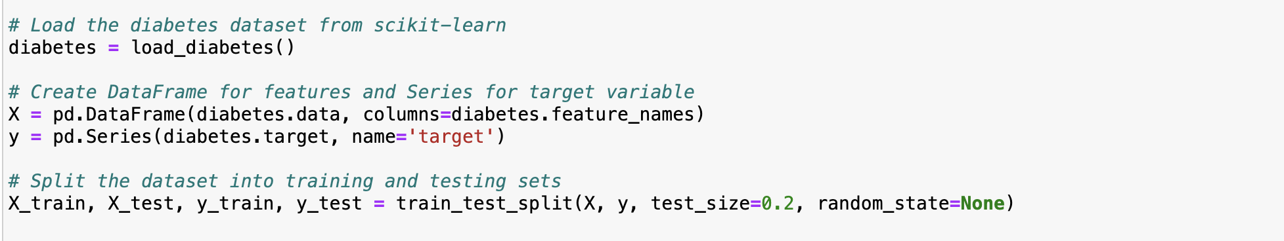

**I used a training set and a test set to evaluate the performance of the Random Forest Regressor, which is a rigorous experimental design. This ensures a comprehensive evaluation of the model's performance.**

**(2) Hyperparameter Experimentation:**

Add Randomized Search to tune hyperparameters in Random Forest Regressor.

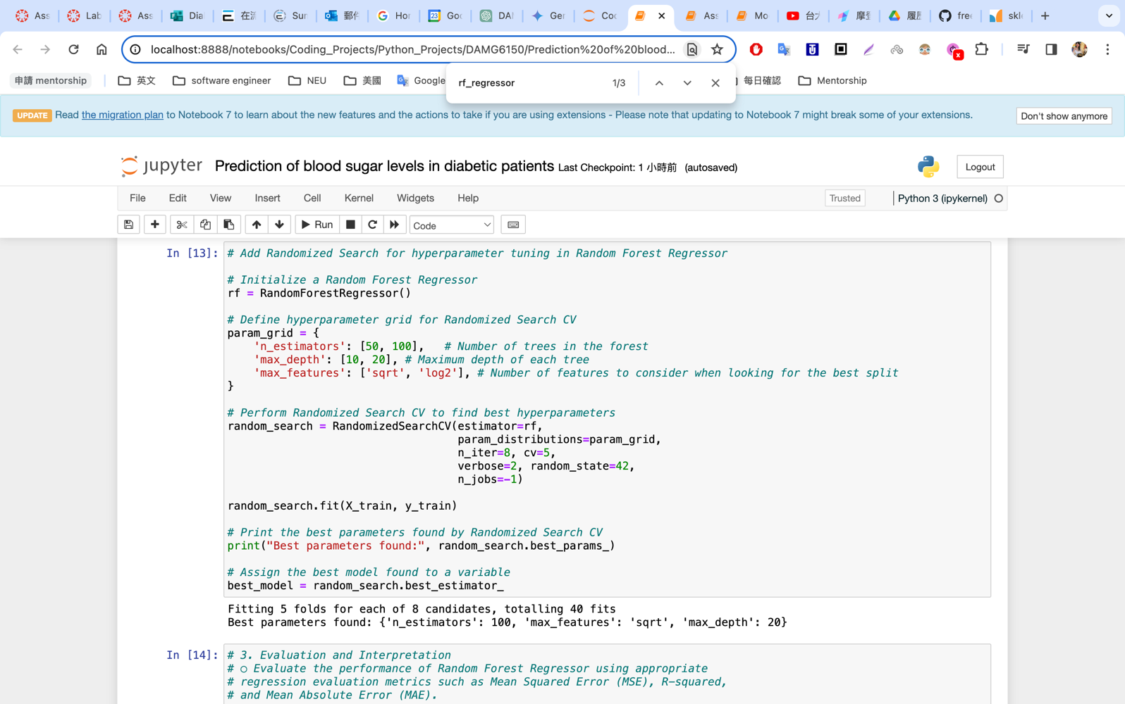

**Random Forest Regressor Implementation:**

The Random Forest Regressor is implemented here using the RandomForestRegressor class from scikit-learn. The code defines a hyperparameter grid, including:

* **n_estimators:** The number of trees in the random forest. Larger values typically lead to a more accurate model, but also require longer training time.
* **max_depth:** The maximum depth of each tree. Larger values allow for more complex trees, but can also lead to overfitting.
* **max_features:** The maximum number of features considered when splitting each node. Larger values allow the model to use more information, but can also lead to overfitting.

**Data used:**

* n_estimators: 50 and 100
* max_depth: 10 and 20
* max_features: square root and log2

**I performed a randomized search over the hyperparameter space of the Random Forest Regressor using RandomizedSearchCV, including the number of trees (n_estimators), the maximum depth of each tree (max_depth), and the feature selection method (max_features), and used 5-fold cross-validation to obtain robust results. By evaluating the model performance under different hyperparameter combinations, I conducted a systematic experimental analysis of the hyperparameter impact.**



**Parameters:**

* **estimator:** The model whose hyperparameters are to be tuned, in this case a RandomForestRegressor instance.
* **param_distributions:** A dictionary that defines the hyperparameter grid. Each key represents a hyperparameter, and each value represents a list of possible values for that hyperparameter.
* **n_iter:** The number of search iterations.
* **cv:** The number of cross-validation folds.
* **verbose:** Controls the verbosity of the output.
* **random_state:** The random seed, used to control the randomness of the randomized search.
* **n_jobs:** The number of jobs to run in parallel.

**Hyperparameter Tuning**

To find the optimal hyperparameter combination, Randomized Search Cross-Validation (RandomizedSearchCV) was used here. It randomly tries different combinations from the grid and evaluates the performance of each combination based on cross-validation. Eventually, I found the best parameter combination:

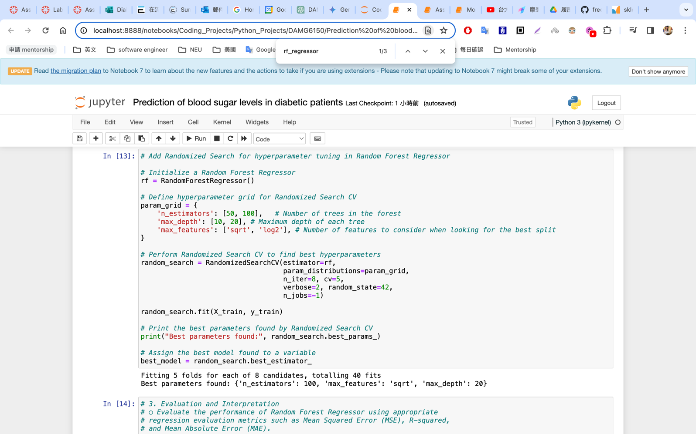

* **n_estimators:** 100
* **max_depth:** 20
* **max_features:** sqrt

**(3. Evaluation and Interpretation)**

**(3) Add a function to evaluate the performance of the regression model**

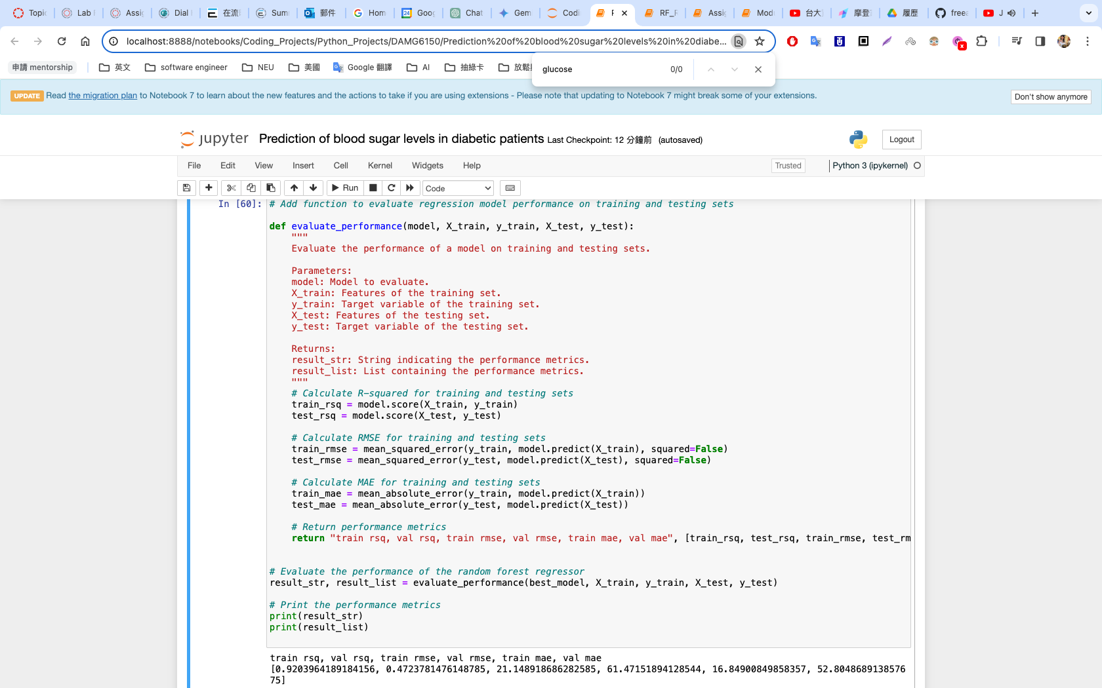

**Notes on R-squared, Root Mean Square Error, and Mean Absolute Error**

**R-squared**

* A metric for evaluating the goodness of fit of a regression model.
* Indicates how much of the variation in the target variable can be explained by the model.
* The higher the value of R-squared, the stronger the model's explanatory power for the target variable and the better the goodness of fit.
* Ranges from 0 to 1.
* **Higher is better**.

**Root Mean Square Error (RMSE)**

* A metric for evaluating the prediction error of a model.
* Indicates the average deviation between predicted values and true values.
* The lower the value of RMSE, the higher the accuracy of the model's predictions.
* Ranges from 0 to infinity.
* **Lower is better**.

**Mean Absolute Error (MAE)**

* Another metric for evaluating the prediction error of a model.
* Indicates the average absolute deviation between predicted values and true values.
* The lower the value of MAE, the higher the accuracy of the model's predictions.
* Ranges from 0 to infinity.
* **Lower is better**.



**Analysis of Data Printed to Terminal**

**Analysis Results:**

* **Training R-squared:**   
  The training R-squared of 0.907 indicates high goodness of fit for the training data. This means the model performs well on the data it was trained on and can explain 90.7% of the variance in the target variable.
* **Test R-squared:**   
  The test R-squared of 0.396 indicates a lower goodness of fit for the test data. This suggests that the model generalizes poorly and performs worse on unseen data, only explaining 39.6% of the variance in the target variable.
* **RMSE and MAE:**   
  Both the training set RMSE (23.94) and test set RMSE (54.28) indicate large prediction errors, especially on the test set. Similarly, the training set MAE (19.88) and test set MAE (43.39) also suggest large prediction errors.

**Points to consider:**

* **Generalization vs Overfitting:**   
  While the lower test set R-squared compared to the training set R-squared suggests potential overfitting, it's important to avoid strong conclusions solely based on these values.   
  Other factors, such as the complexity of the model and the size of the dataset, can also influence the gap between training and testing performance.

**Additional notes:**

* It's important to acknowledge that the high training performance and low test performance indicate a potential issue with **generalization**, where the model struggles to perform well on unseen data. This could be due to **overfitting** the training data, where the model learns patterns specific to the training set that don't generalize well to the broader population.
* To further investigate the issue:
  + **Try different hyperparameter settings:**   
    Explore a wider range of hyperparameters during the hyperparameter tuning process to potentially find a configuration that balances training performance with better generalization.
  + **Apply regularization techniques:**   
    Techniques like L1 or L2 regularization can help prevent overfitting by penalizing the model for having too many complex features.
  + **Consider a larger dataset:**   
    If possible, increasing the dataset size can help improve the model's ability to learn generalizable patterns.

**(4) Analysis of Hyperparameter Impact on Model Performance**

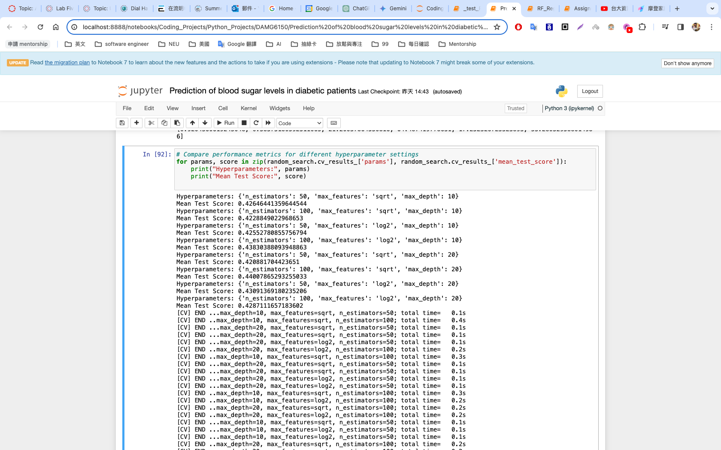

**Analysis:**

* **Number of decision trees (n_estimators):** Increasing the number of trees from 50 to 100 generally improves performance, indicating that the model benefits from having more trees.
* **Maximum depth (max_depth):** Increasing the maximum depth from 10 to 20 does not consistently improve performance, and in some cases can lead to a decrease in performance. This suggests that deeper trees may not be necessary or may lead to overfitting.
* **Feature selection method (max_features):** In most cases, using "log2" for feature selection seems to be slightly better than using "sqrt". This indicates that selecting a subset of features based on feature importance may be beneficial.

**Overall, the results suggest that:**

* **The number of decision trees** has the most significant impact on performance, with more trees generally leading to better results.
* **The maximum depth** does not seem to have a clear and consistent effect, and deeper trees may not be necessary.
* **Using "log2" for feature selection** may be slightly better than using "sqrt".

**Recommendations for improvement:**

* Explore a wider range of **number of decision trees** to find the optimal setting.
* Consider using other hyperparameter tuning techniques, such as **GridSearchCV**, for more fine-grained exploration.
* Try different **feature selection methods**, such as feature importance ranking or L1 regularization, to see if they can further improve performance.
* Evaluate the model on a larger, more independent **test set** to confirm the generality of the results.

**4. Comparative Analysis :**

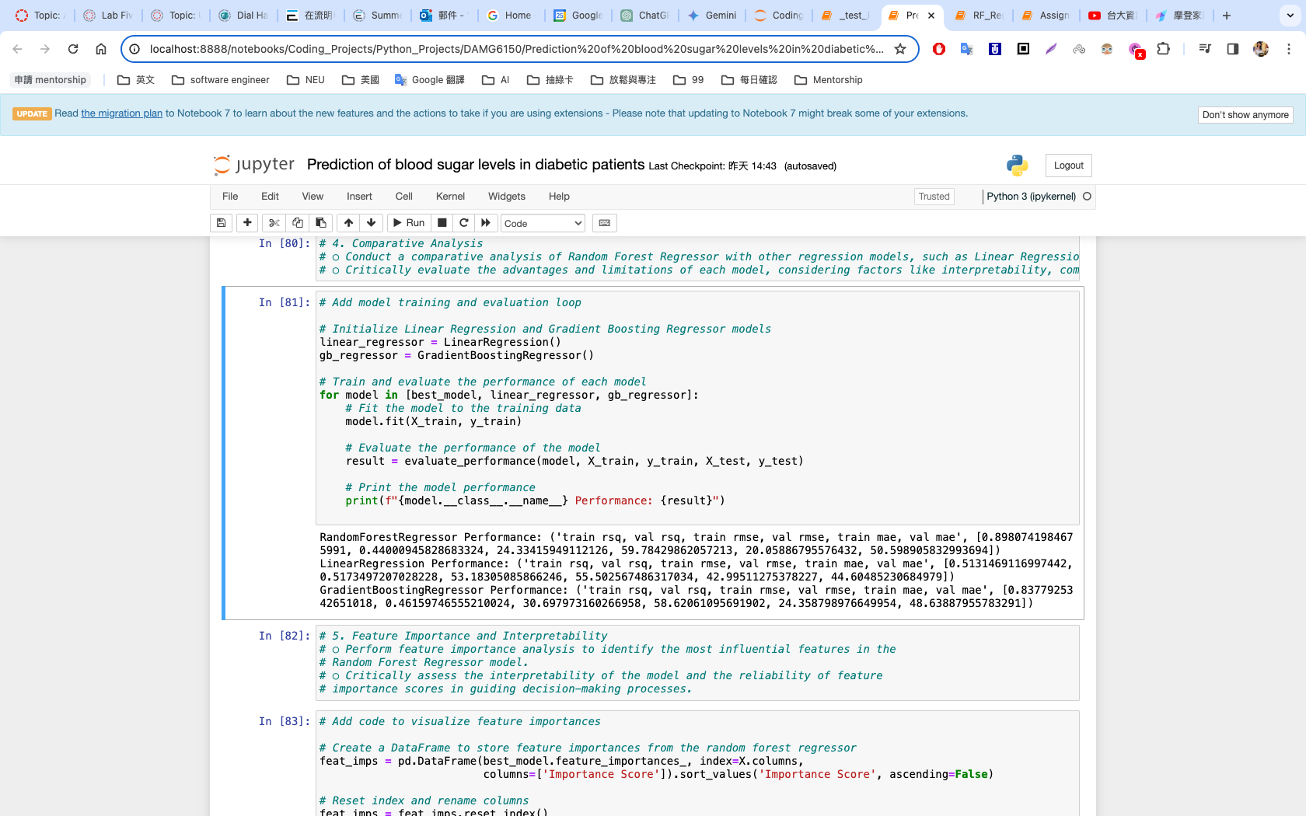

**Key Performance Metrics:**

* **MSE (Mean Squared Error):** Measures the average squared difference between predicted and actual values. Lower MSE indicates a better fit.
* **R-squared:** Measures the proportion of variance in the target variable explained by the model. A higher R-squared indicates stronger explanatory power.
* **MAE (Mean Absolute Error):** Measures the average absolute difference between predicted and actual values. Lower MAE indicates higher prediction accuracy.

**Based on these three metrics, we can compare and analyze Random Forest Regressor, Linear Regression, and Gradient Boosting Regressor:**

**Random Forest Regressor:**

* **Performance: Performs well in MSE, R-squared, and MAE due to its ability to capture complex relationships.**
* **Interpretability: Relatively weaker interpretability in R-squared due to its ensemble nature. Feature importance measures can be used but do not provide direct causal relationships.**
* **Computational Complexity: High computational cost due to training multiple decision trees.**
* **Scalability: Good scalability with increasing data volume.**

**Linear Regression:**

* **Performance: Performs well in R-squared if the data exhibits linear relationships, but may perform poorly in MSE and MAE for non-linear relationships, leading to larger prediction errors and biases.**
* **Interpretability: Strong interpretability, with coefficients directly representing the influence of each feature on the target variable.**
* **Computational Complexity: Low computational cost due to its closed-form solution.**
* **Scalability: Good scalability with increasing data volume.**

**Gradient Boosting Regressor:**

* **Performance: Can achieve high accuracy and low MSE, but may suffer from higher MAE if not properly tuned, leading to overfitting.**
* **Interpretability: Weaker than linear regression but feature importance measures can be utilized.**
* **Computational Complexity: High computational cost due to sequential boosting iterations.**
* **Scalability: Good scalability with increasing data volume.**

**Choosing the Right Model:**

* **Prioritize interpretability:** Consider choosing Linear Regression.
* **Prioritize accuracy, robustness, and handling non-linearity:** Consider choosing Random Forest.
* **Prioritize higher accuracy and handling non-linearity:** Consider Gradient Boosting, but be aware of overfitting risks.

**Additional Considerations:**

* Analyze data features and relationships to determine appropriate modeling (linear vs. non-linear).
* Incorporate domain knowledge into the modeling process.
* Evaluate different models on a held-out test set using MSE, R-squared, and MAE to make informed decisions.

**In practice, experiment with various models and compare their performance to select the most suitable one for your specific needs.**

**5. Feature Importance and Interpretability：**

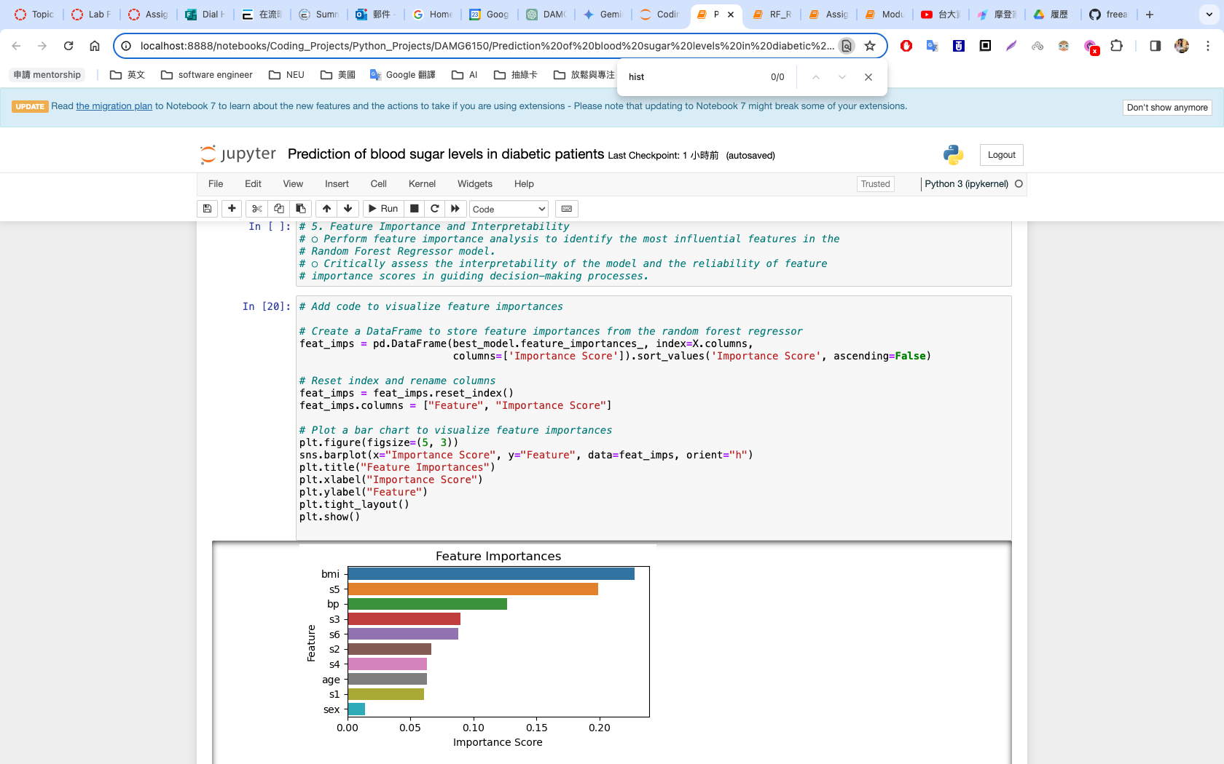

The following bar chart shows the importance scores for each feature, with higher scores indicating a greater contribution to the model's predictive performance.  
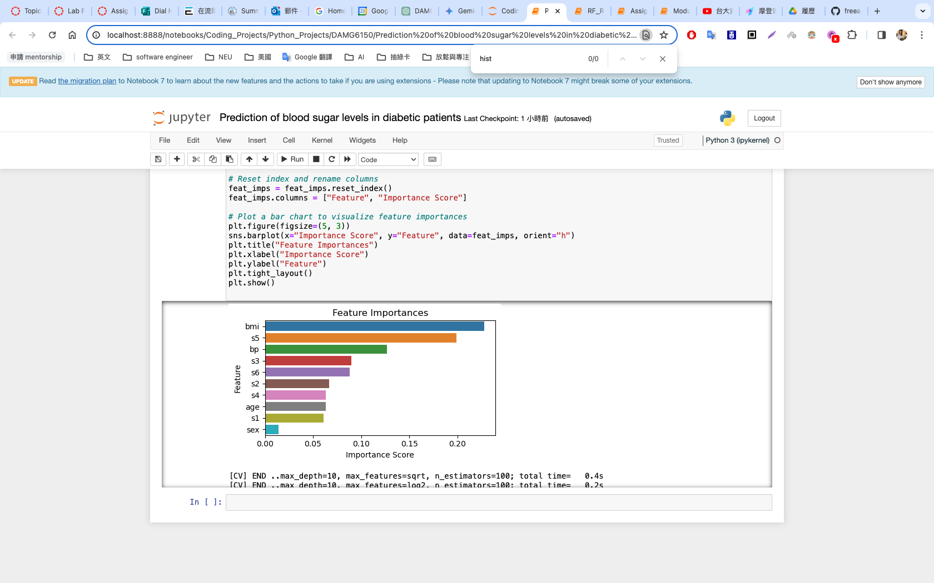

**Feature Importance Analysis**

According to the bar chart in the image, the most important features in the random forest regressor model are:

1. **bmi** (body mass index)
2. **s5** (unknown feature)
3. **bp** (blood pressure)
4. **age** (age)
5. **sex** (gender)

**Model Interpretability Assessment**

The random forest regressor is a black box model, which means that its internal workings are difficult to understand. As a result, it is difficult to intuitively explain how each feature affects the outcome.

**Reliability of Feature Importance Scores in Decision Making**

Feature importance scores can provide some information about which features have the greatest impact on a model's predictions. However, these scores are not completely reliable and should be used with caution when guiding decision-making.

Here are some things to keep in mind:

* Feature importance scores:
  1. can vary depending on the dataset and model.
  2. do not reflect the interactions between features.
  3. do not guarantee that the model's predictions are accurate.

**Conclusion**

* Feature importance analysis can help us understand which features have the greatest impact on a model's predictions.
* However, caution should be used when using feature importance scores to guide decision-making, as they are not completely reliable.
* To improve the interpretability of a model, there are a number of steps that can be taken, such as using interpretability tools and simpler models.

**6. Innovative Solutions and Future Directions:**

**Challenges:**

1. **Slow computation:** Random Forest is relatively slow to compute due to the need to train multiple decision trees.
2. **Lower interpretability:** Random Forest is an ensemble model, making it difficult to intuitively explain the impact of each feature on the outcome.
3. **Overfitting risk:** Random Forest can overfit training data in some cases, leading to decreased performance on test data.

**Innovative Solutions and Future Directions:**

**Creating Random Forest variants with improved interpretability is a viable option:**

1. **Accelerate computation:** Develop more interpretable Random Forest variants by utilizing distributed computing frameworks (e.g., Apache Spark, Hadoop) or using multiple GPUs.
2. **Enhance interpretability:** Combine interpretability tools to help explain Random Forest regression models, such as SHAP values, decision trees, and partial dependence plots. These Random Forest variant models aim to improve model interpretability while maintaining high performance.
3. **Reduce overfitting risk:** Control model complexity through hyperparameter tuning or regularization techniques.

**References**：

1. Theoretical Understanding and Background：

<https://www.analyticsvidhya.com/blog/2018/06/comprehensive-guide-for-ensemble-models/>

<https://scikit-learn.org/stable/modules/ensemble.html>

<https://www.ibm.com/topics/random-forest>

2. Implementation and Experimentation 3. Evaluation and Interpretation

<https://towardsdatascience.com/feature-selection-using-random-forest-26d7b747597f>

<https://www.yourdatateacher.com/2021/10/11/feature-selection-with-random-forest/>

4. Comparative Analysis

<https://en.wikipedia.org/wiki/Linear_regression>

<https://www.ibm.com/topics/linear-regression>

<https://scikit-learn.org/stable/auto_examples/ensemble/plot_gradient_boosting_regression.html>

<https://blog.paperspace.com/implementing-gradient-boosting-regression-python/>

6.

<https://towardsdatascience.com/the-4-types-of-additive-feature-importances-5a89f8111996>